Eastern Region Big Weekend – Senior Championships
The Eastern Region Big Weekend was held at St.Neots over the weekend of 14/15th of May, with coaching, refereeing and armoury courses held on the Saturday as well as a youth training day. The Sunday was a 6 weapon competition. It was a well-attended and well run event with people coming from across the region to attend the courses and the competition.
Huntingdonshire fencing club had members fencing in all events except the women’s epee competition. There were 16 club members across the weapons with Silvia Brown and David Soalri fencing two weapons! There were three medallists and four best veterans prizes also won.
In Men’s Foil there were 5 club members: Jacques Portal, Richard Sage, David Solari, Dan Summerfield and Joshua Coates. Jacques fencing well only dropped two fights in his poule earning him the rank of 5th after the poules. He went on to win his first Direct Elimination (DE) fight 15-5 to enter the last 8, he then won the next DE 15-13 in a hard fought fight. Having now made the semi-finals he fought the 1st seed Bomba Brown who in a high energy fight took the fight 15-5, with a closer fight than score reflects Jacques finished the competition 3rd and also took the highest placed veteran fencer award. Many congratulations to Jacques on his high standard of fencing all day and his well-deserved medal.
Richard Sage, Joshua Coates and Dan Summerfield were in the same pool winning 3, 2 and 3 fights respectively. Placing them 15th, 20th and 16th after the poule. Richard won his first DE 15-3 to make it to the last 16 before losing 9-15 to the eventual 3rd place fencer, who was also in the same poule as Joshua, Dan and Richard. Joshua won his first DE 15-11 in a close fight before being beaten by a difficult left hander 7-15 in his second D.E who was beaten in the next round by Jacques Portal. Dan won his first D.E convincingly at 15-1, he then lost in a tough fight to the number one seed 10-15. Final places were 11th, 14th and 12th respectively. David Solari having fought in the Sabre competition in the morning came up against difficult opponents in his poule gaining a win and narrow loss of 4-5 against the eventual winner of the competition. David was ranked 24th after the poule but had to withdraw before the D.E round.
In Men’s Epee there were 4 club members: Jean-Luc Janet, George Partridge, Tim Bissell and Andrew Brown. They won 3,4,2 and 2 fights in their poules respectively, placing them 6th, 3rd, 8th and 10th going into the D.E Round. Andrew had a tough fight against a higher seed losing only 8-15 to finish 10th in the competition. Jean-Luc and Tim both won their first D.E in close fights of 15-13 and 15-14. Tim then went on to fight for a place in the semi-finals narrowly missing out 11-15 to his opponent, finishing 8th overall.
Jean-Luc and George were then drawn against each other to fight for a place in the semi-finals and be guaranteed a medal. It was a hotly contested fight with Jean-Luc putting out the higher seeded George 15-9. Jean-Luc continued to usurp the rankings by putting out the number two seed 15-14 securing a place in the final. After several successive tough fights to reach the final Jean-Luc cruised to victory 15-7 over his opponent who was outmatched and out fence, also winning best veterans prize. Well done to Jean-Luc who went from strength to strength throughout the competition beating higher seeded fencers all the way to the gold medal.

In Men’s Sabre there were 3 club members: Euan Smith, Dan Tozer and David Solari. They won 2, 1 and 1 fights in their poules respectively, placing them 6th, 9th and 10th going in to the D.E round. Euan won his first D.E 15-6 before going out 5-15 to the 3rd seed in the last 8 stage of the competition, meaning he finished 6th and also took top placed veteran. Dan beat his higher seeded opponent in his first D.E 15-11 to get into the last 8, where he lost to the 1st seed and eventual winner 8-15 in a difficult fight, finishing 8th in the competition. David had a strong fight against a higher seeded opponent only losing 10-15 to hold his positon of 10th in the competition.
Women’s Sabre entrants from the club was Silvia Brown who won 2 out of 3 poule fights to be ranked 2nd. Silvia won her first D.E 15-10 to reach the finals where in a close fought fight she lost 11-15 to secure 2nd place as well as the prize for highest placed veteran.
In Women’s Foil the club was represented by Tracey Coates, Hannah Smyth, Silvia Brown, Lena Smith and Rachel Burden. They won 3, 2, 2, 2 and 0 fights respectively in their poules, this placed them at 5th, 8th, 10th, 11th and 14th in the competition. Tracey won her first D.E 15-3 to make the last 8 but lost against a higher seeded opponent in her fight to get to the semi-finals 6-15, finishing 6th overall. Hannah beat her first D.E opponent of equal rank 15-8 to make the last 8 before losing a close fight 12-15 against the 1st seed, finishing 7th in the competition.
Silvia fresh from her silver medal in the sabre competition fenced the foil event winning her first D.E 15-11 against a higher ranked opponent to enter the last 8. Her second D.E was a close fight ending 12-15 with Silvia applying great pressure on her opponent taking successive hits to close the gap before her opponent managed to get the final hit. Silvia finished 8th in the competition. Lena fought a tough fight against a higher seeded opponent to finish 11th after her fight ended 12-15. Rachel drew the 3rd seed as a first D.E and wasn’t able to answer the more experienced fencers technique losing 4-15, placing her 14th overall.

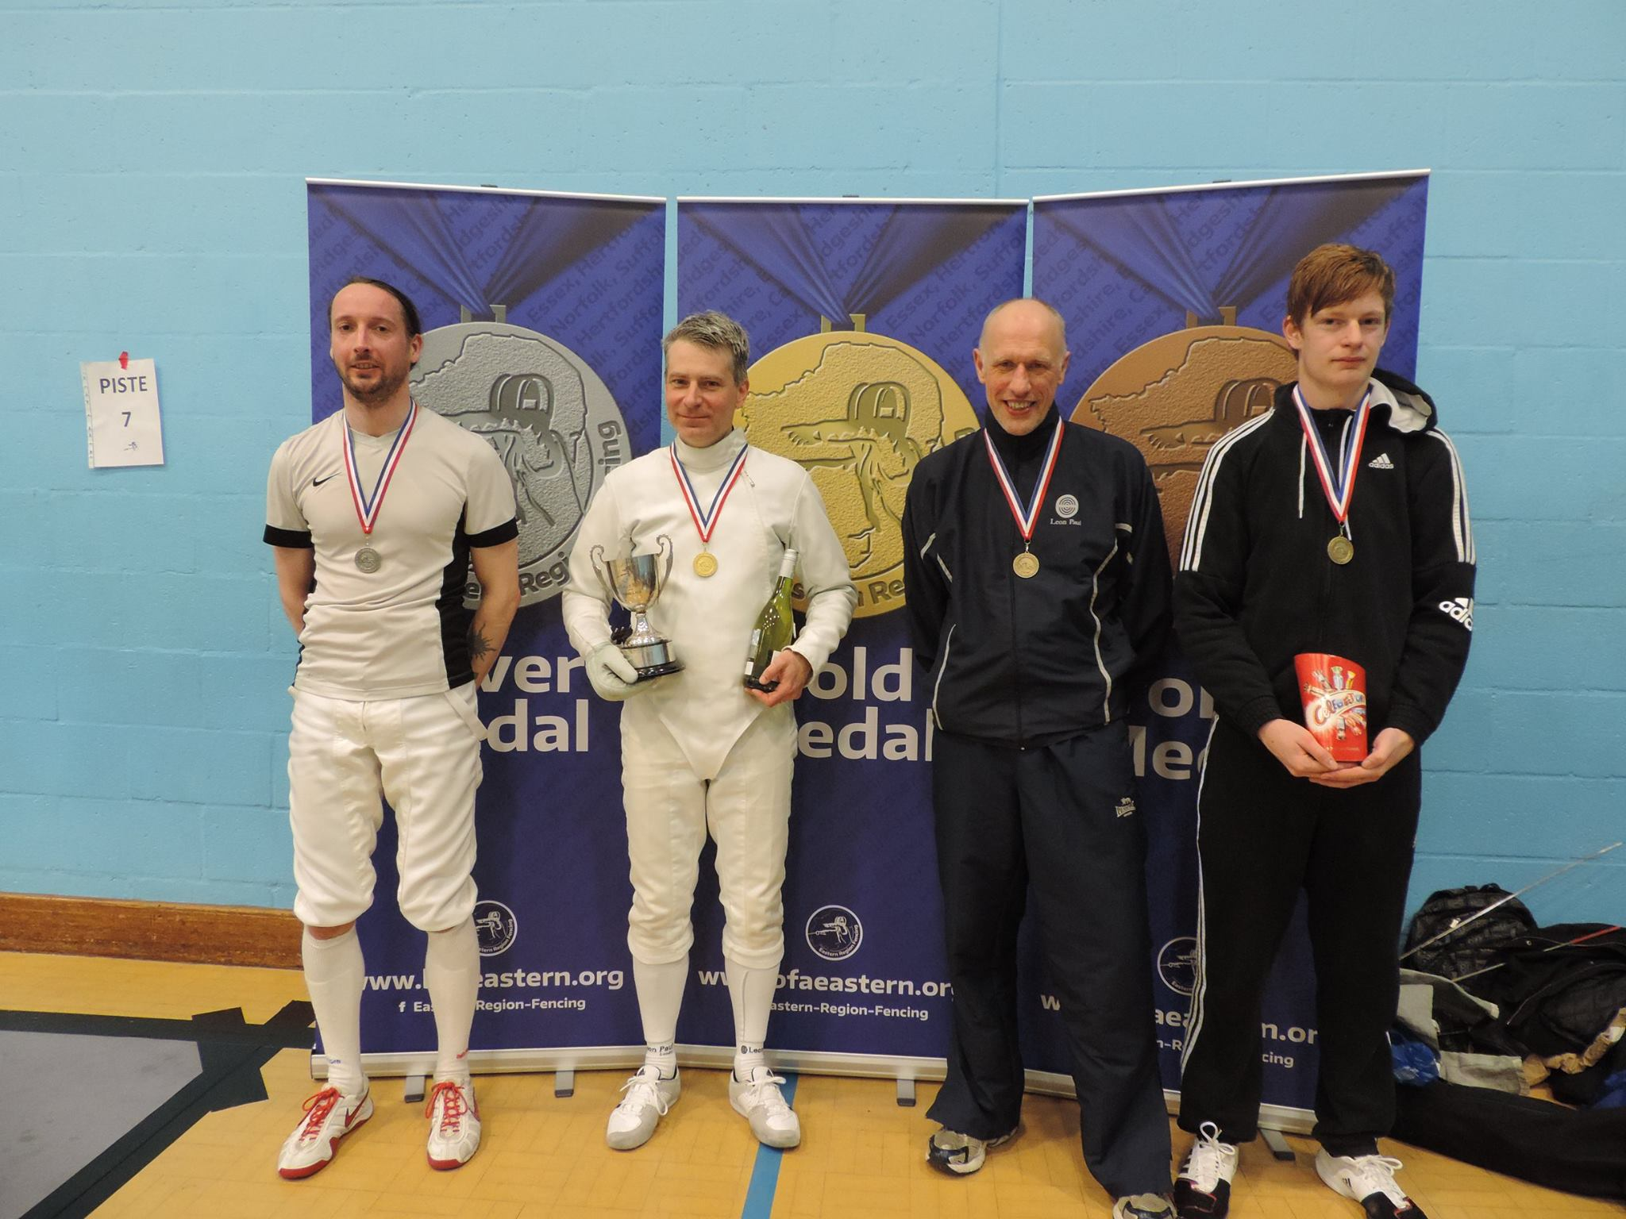
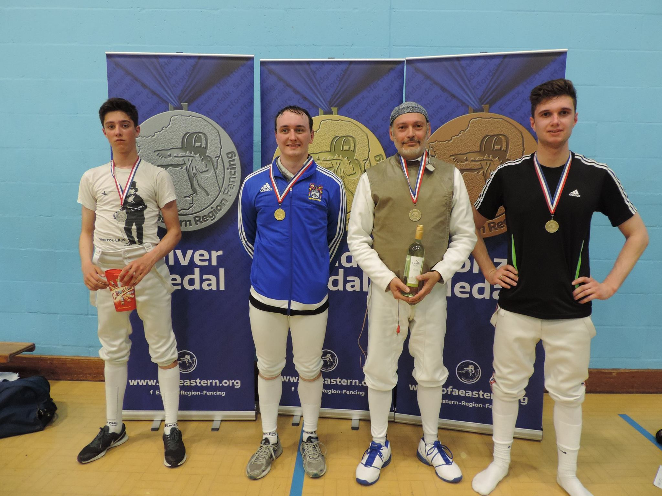
Jean-Luc Janet gold medallist and best veteran.
Jacques Portal bronze medallist and best veteran.
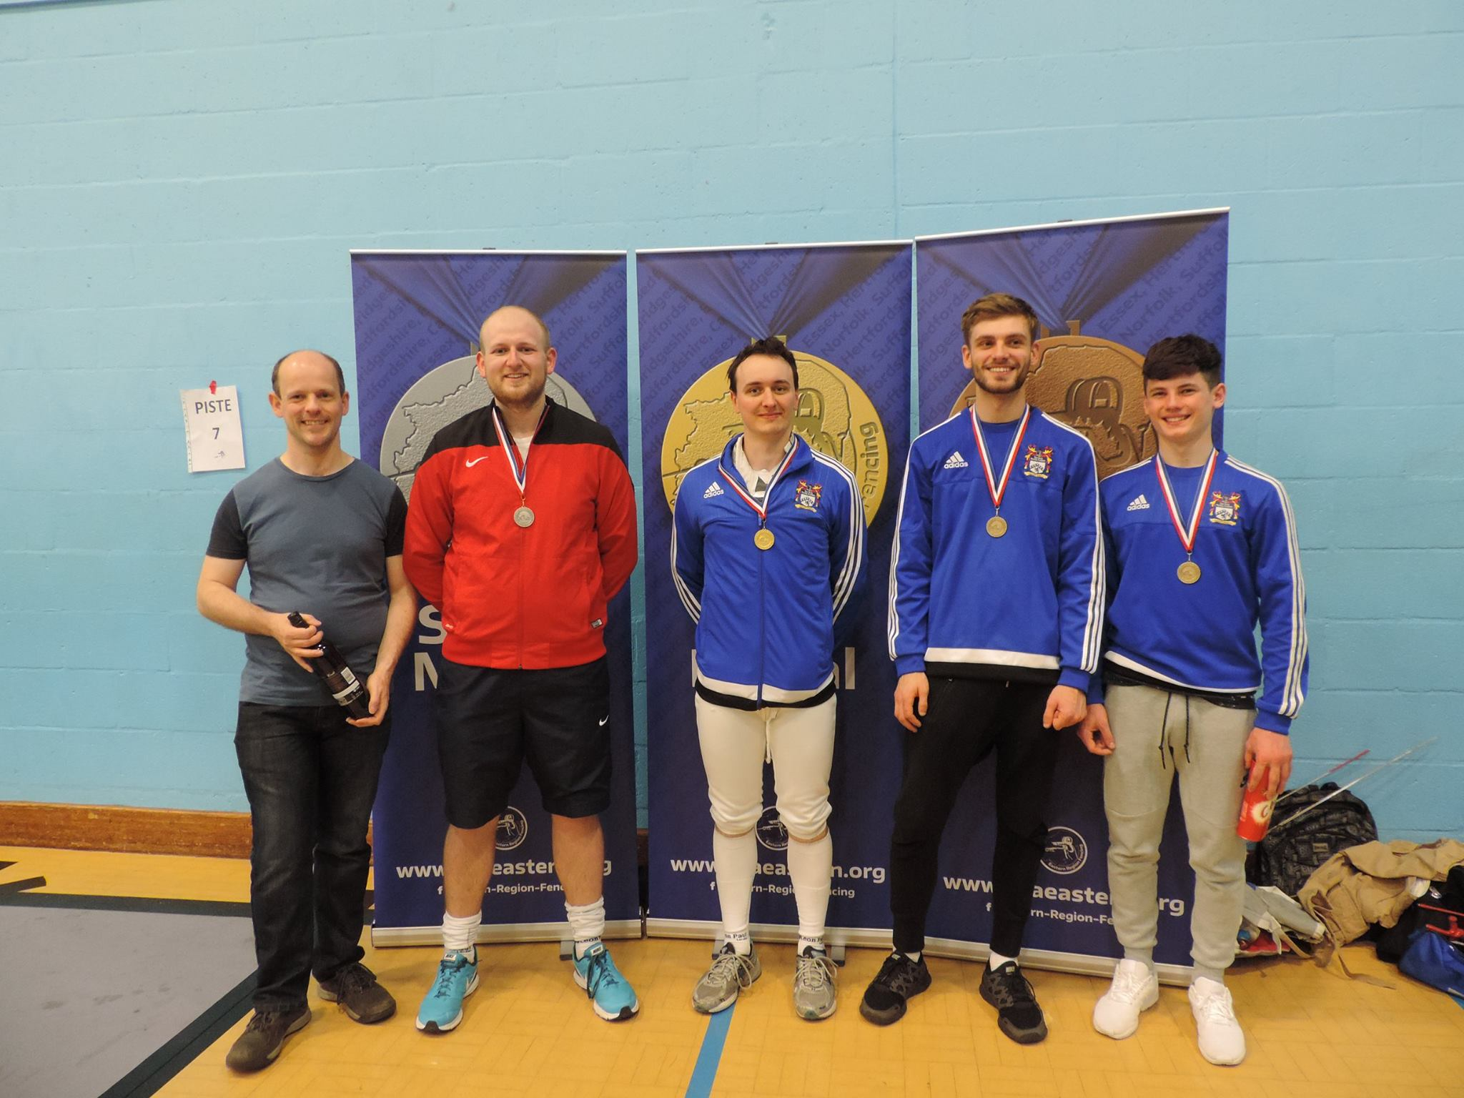
Euan Smith with prize for best veteran.
Silvia Brown with silver medal and prize for best veteran.

